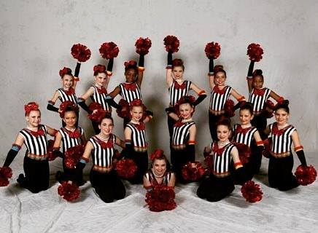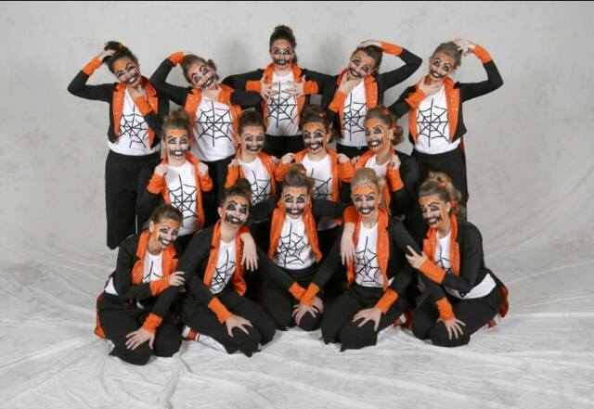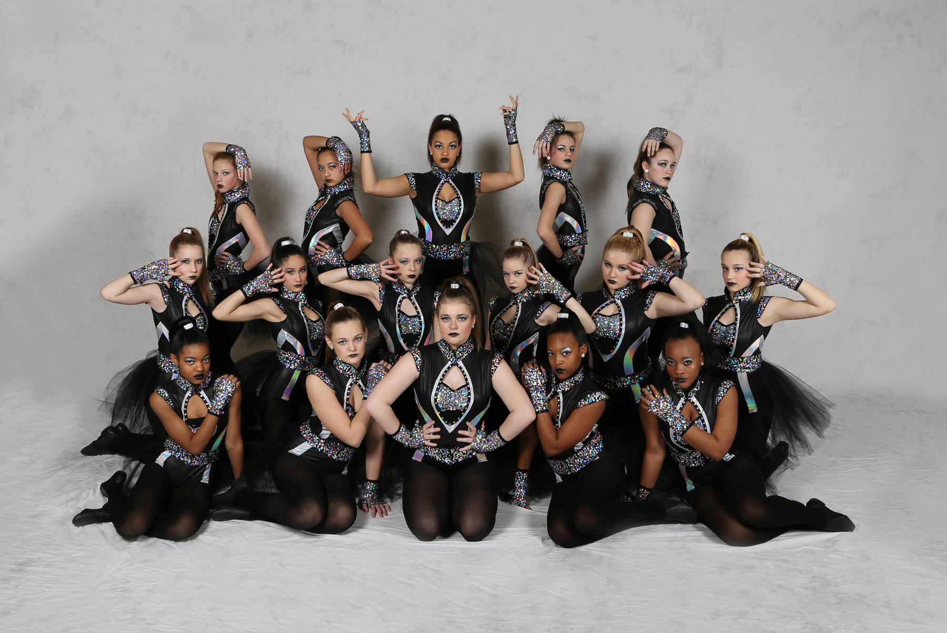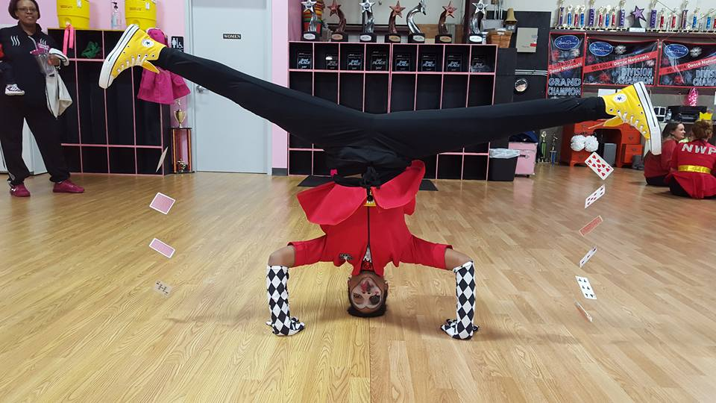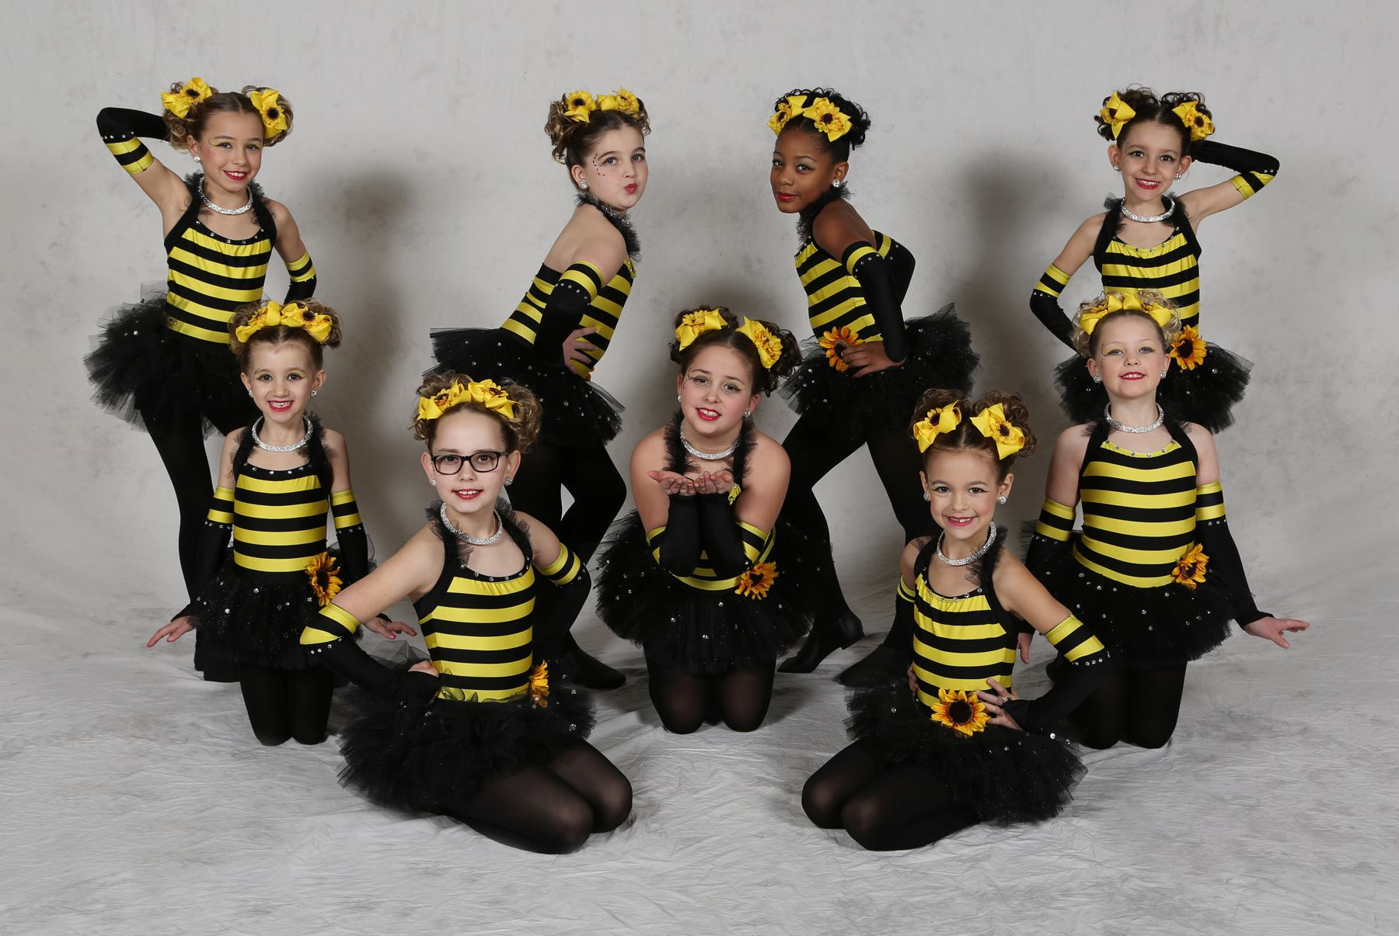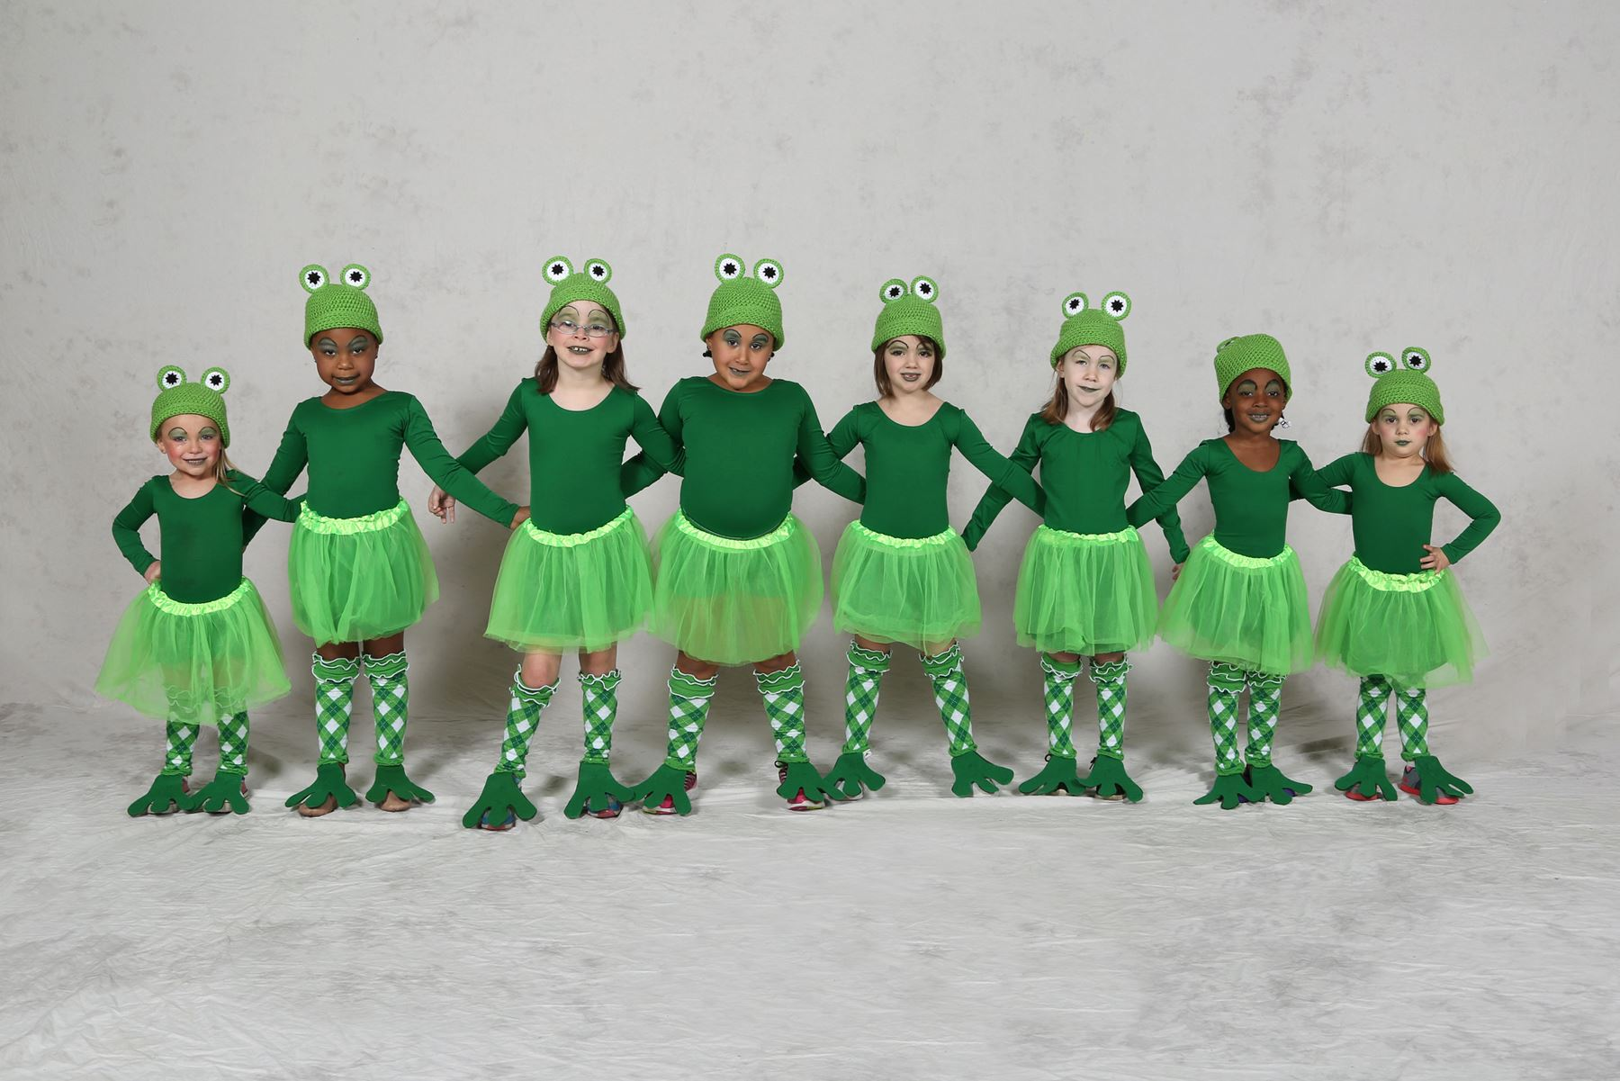 POM HIP-HOP JAZZ
www.nwpdanceteam.com
or “like”  us on Facebook under Northwest Productions

Northwest Productions Dance Team (NWP) is holding auditions for the 2016-17 competition season. We are a nationally ranked champion dance team and are completing another very successful year. We offer a positive, competitive, and family dance experience in the pom, jazz, and hip-hop categories. Our program promotes confidence, discipline, leadership, values, and a love for dance.

Youth, Junior and Senior girls must be present for all dates listed below to learn the try-out routine. Please note that the final audition is at our studio on May 13th. Additional information regarding the teams will be passed out the first night of auditions. Team and registration information, along with try-out dates are as follows:

TINY & MINI TEAM REGISTRATION BY MAY 13TH:
E-mail khnorthwestproductions@yahoo.com
Tiny Team (3-6 years as of 8/31/2016)
Mini Team (6-9 years as of 8/31/2016)

AUDITIONS FOR YOUTH, JUNIOR, PREP & SENIOR TEAMS:

May 11& 12 May 13
White Oak Middle School NWP Studio
3130 Jessup Road, Cinti, OH 45239 5894 State Rte. 128, Cleves, OH 45002

5-7pm: YOUTH or YOUTH PREP - 12 years and younger as of 8/31/2016
7-9pm: JUNIOR OR JUNIOR PREP - 15 years and younger as of 8/31/2016
7-9pm: SENIOR - 18 years and younger as of 8/31/2016

FREE Open Dance Classes Offered for auditions:
These classes are optional to work on dance technique to prepare for auditions.
Please register at khnorthwestproductions@yahoo.com.
6:30pm-8pm: May 3-5

More Information:
Kelly Hullinger 513-702-7039
E-mail khnorthwestproductions@yahoo.com

RECREATIONAL CLASSES available for the Fall!

